PRATIBHA INDUSTRIES LIMITED
BOARD OF DIRECTORS
Sr. No. | Name & Designation | Photograph
1 | Mrs. Usha Bhagwan Kulkarni  Chairperson | 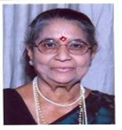
2 | Mr. Ajit Bhagwan Kulkarni  Managing Director | 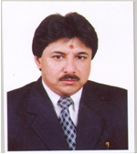
3 | Mr. Ravi Ajit Kulkarni  Whole Time Director | 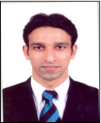
4 | Mr. Sharad Prabhakar Deshpande  Whole Time Director | 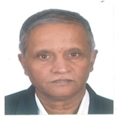
PRATIBHA INDUSTRIES LIMITED
BOARD OF DIRECTORS
Sr. No. | Name & Designation | Photograph
5 | Mr. Awinash M. Arondekar  Independent Director | 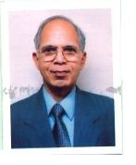  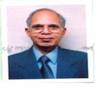
6 | Mr.Shrikant T. Gadre  Independent Director | 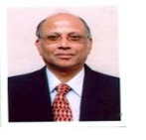
7 | Mr. Vilas Parulekar  Independent Director | 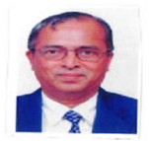
8 | Mr. V. Sivakumaran  Independent Director | 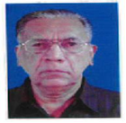
9 | Prof. S. L. Dhingra  Independent Director | 